Art History Study guide ch.7
Name_____________________________________________

- Why did Early Christians use symbolism in their artwork?

- Name two reasons early Christians used catacombs.
1.
2.

- What did Constantine do for the Roman Empire?

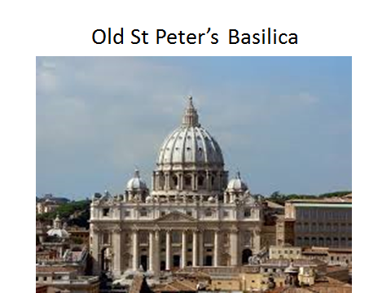Who built this Basilica?

- What were Byzantine mosaics mostly made out of?

- What Basilica is this: 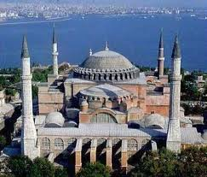_____________________

- Hagia Sophia started out as a Christian church and later converted into a ___________________.
- What is a Nave
- Emperor Justinian Built what main church?
- What Basilica is this? 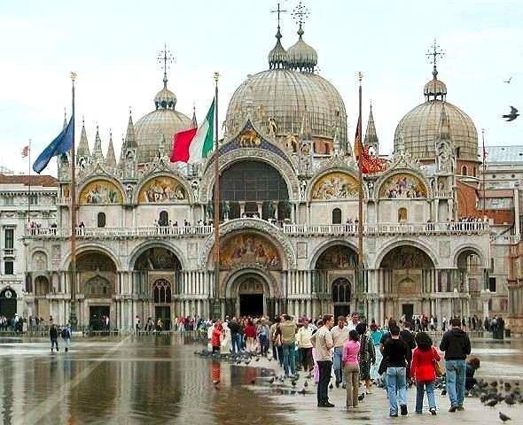

- What is the Holy book of Islam?
- What is an Arabesque:

- What is an Illumination:

- What is a Mosque:

- What is the most famous court in the Alhambra Palace?

- What did Charlemagne invent?

- Describe Monastic Life:

- What type of script is the Koran written in?

- 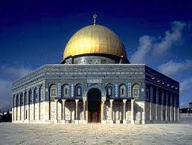 What is the name of this Mosque?

- What city is the Above Mosque located in and why is it Sacred?

- Name a fresco in St Peter’s Catacomb:

