Art History Study Guide Ch. 5 & 6
Name_______________________________________________
- Study Quizzes 3&4
- Where was the first cave painting found?
- “Venus of Willendorf” symbolized what?
- The City of Jericho lies in what country?
- Where is Stonehenge?
2 examples of what Stonehenge could be used for:
1.
2.
- Ancient Mesopotamia lies between what 2 rivers?
What is a Ziggurat, what was it used for, and how many staircases:

- Why do the Hanging Gardens of Babylon appear to be hanging?

- What river watered the Hanging Gardens of Babylon?
- What were tombs built for?

- An ancient Egyptian King is called what?
- Who is Imhotep?

- What was the first pyramid?
- What type of stone was used to build the great pyramids?
- What does the inside of a tomb look like?

- What is a Sphinx?

New Kingdom was the _________________ age in Egypt’s history.

Pylon:

Hypostyle Hall:

Descriptive Perspective:

Fresco:

Mummification:

- Who were the Minoans and where did they live?

- Who were the Mycenaeans and where did they live?

- What is happening in the “Bull Dance Fresco”?

- The Greeks Depicted their Gods in what form?
Contrapposto:

- Name a Greek sculpture that is standing in Contraposto stance.

- Tell me about the Greek Olympics
- The winning athletes in the Olympics would be awarded 3 things:
1.
2.
3.
- The Nike of Samothrace was originally placed where?

- 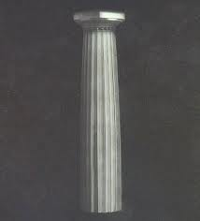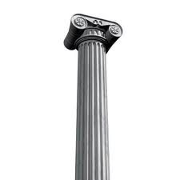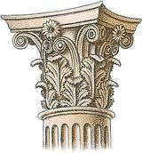

______________ _____________ ______________________

- What are these? 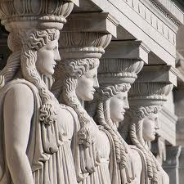
- What mosaic is Alexander the Great in?
- What was the Colosseum used for?

- What is the Awning that stretched out over the top of the Colosseum?

- 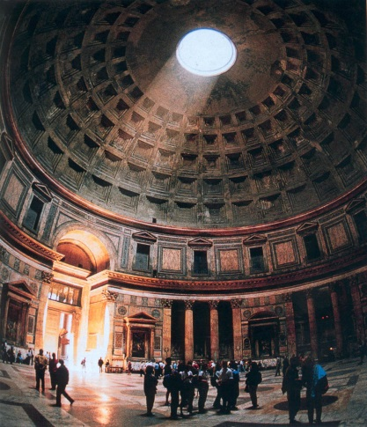 What building is this?

- 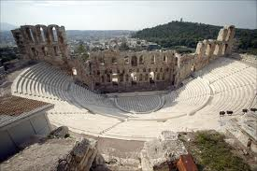 What Theater is this?

- 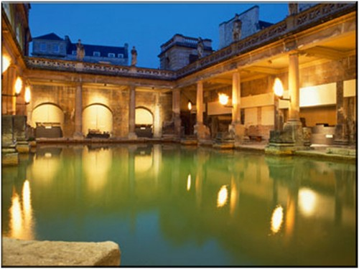

Name this place, and what it was used for:

